Catherine Maloney

Professor Kevin Ryan

CS - 110

13 December 2020

Final Project Report

For my project, I answered the question “How has airport traffic been affected by the COVID-19 pandemic across various airports across the globe?” My data was downloaded from Terence Shin’s csv file “COVID-19’s Impact on Airport Traffic” on Kaggle.com. The target audience for this program could possibly be scientists researching the effects of the COVID-19 pandemic or police departments monitoring daily traffic to see what to expect for their job.

When the program runs, an introduction statement appears explaining the purpose of the code and the time period the data was collected. The program then asks the user to input a month and day within the time period, to which I used 7/8/2020 as an example. Lastly the average percent of baseline for the volume of traffic for 7/8/2020 is calculated, along with an explanation of the number that was presented.

To begin, I downloaded the csv file, which had the following columns:

The columns needed for my code are “date” and “percent of baseline.” To simplify the dataset, I deleted the columns “Version,” “Centroid,” “ISO_3166_,” and “Geography.” The data collected for this file was traffic volume to and from each airport in the dataset from March 16, 2020 to October 16, 2020, during the COVID-19 pandemic. The countries in which the airports are located in are the United States, Canada, Chile, and Australia. I created a print statement to explain the purpose of my code before asking for the user’s input. The baseline period for this dataset was a month and a half before the pandemic, February 1, 2020 to March 15, 2020. The percent of baseline is the proportion of trips on the date specified, versus the average number of trips during the same day of the week in the baseline period. For example, April 10 was a Friday. The volume of traffic to and from the specified airport on that day was compared to the average volume of traffic to and from the same airport for every Friday during the baseline period.

The goal of my code was to prompt the user to enter any date during the specified period of the pandemic. Once entered, my program was going to find every airport with data collected for that date and average the percent of baseline for each of those airports. The purpose of this average was to paint a bigger picture globally of how much the world halted during the pandemic. The dataset itself only gave the percent of baseline for each airport, which only concluded information about a specific city.

After importing the csv file into my code, I created the variables “month” and “day” to prompt the user to enter the date they want to find traffic information about. I then created the empty list “baseline_list,” to be filled later. Next, I created a “for loop,” to be looped through each row in the file. I created an “if statement” to account for the fact that the first row in the file is just the column titles. So, if the second column in the row was not called “Date,” then the “for loop” would continue to the next row.

Under that “if statement,” I created the variable “date.” I used the string.split() function to separate the month, day, and year of the date by a slash in the “Date” column of the file, so that they would become separate strings. Therefore, the new variable “the_month” denoted the first string of the variable “date,” and the new variable “the_day” denoted the second string of the variable “date.” I then formed two more “if statements.” These were for if the user inputs for “month” and “day” were equal to the separate strings of “the_month” and “the_day” in the “Date” column of the csv file. Once the rows for that date were found, using the list.append() function, the program added the contents of row 3 for those rows (percent of baselines) to the “baseline_list.”

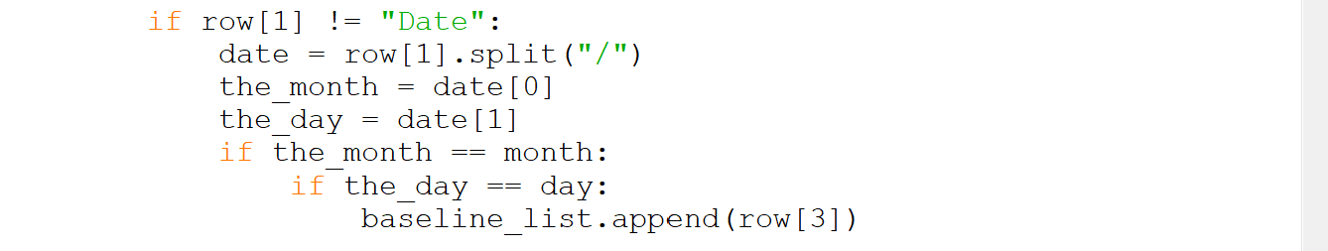

Outside of the “for loop,” I wrote the initial condition “sum = 0,” for the variable “sum” that would be referenced later. I created another “for loop,” to calculate the sum of the integers in “baseline_list.” This was done by adding each integer in the baseline list “i” (part of the “for loop”) to the variable “sum.” The new variable “average” then divided “sum” by the number of dates in the newly appended “baseline_list” using the len() function. Finally, I created a print statement printing the result of the program and an explanation of it.

The biggest challenge I faced while designing my program was understanding how to manipulate the CSV file while working in my Python file. The specific challenges I faced were opening the file in my program and seeing if it was stored in the right place, figuring out how the program would be able to recognize all rows with the same date, and figuring out how I would average the baseline rows aligned with the date rows. To solve these issues, I looked up tutorial videos on how to import and manipulate data in Python. The videos were fairly easy to follow and translate to my own program. I also realized I needed to use some string manipulation to find all rows with the same date, and from there the rest of the code was easier to write.

Lastly, a couple of extensions could be made to my program to maximize its worth. Not only could find the average of the percent of baselines for each date, but also each country, city, and airport to get another type of traffic comparison. Instead of creating individual averages, the user could use multiple inputs such as date and location to narrow down their average. Since the dataset is relatively small, there is not much variation among the types of data inside of it, which does not result in many different extensions to the program.

Sources

Shin, Terence. (2020). “COVID-19’s Impact on Airport Traffic.” [Dataset]. Retrieved from: [COVID-19's Impact on Airport Traffic | Kaggle](https://www.kaggle.com/terenceshin/covid19s-impact-on-airport-traffic)